**Python online course for beginners - not to drown in code altogether!**

**Looking for an efficient course in some basic IT skill that will be just right, teach you all the basic framework thinking about coding, and maybe also, result in getting a new job in this thriving industry? Well, then it seem like it's Python for you now.**

**What's Python, anyway?**

Python is a powewrful, albeit quite easy in learning and relaatively easy in its application, too, programming language. There are dozens of free resources to learn Python online, so far, and there are to be more, definitely.

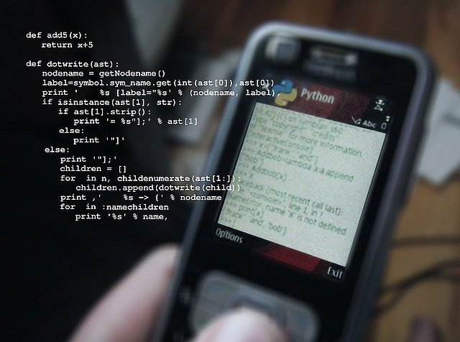

Some of them are paid - as is Vertabelo Academy's course in Python - either a totally introducttory course to Python, or a special, data science dedicated and oriented course, which also, however, which may come as a surprise, targets those who never had any real connection with IT.

**Online Python course from Vertabelo Academy!**

So, if you are looking for a career changer now, think about enrolling in Python course - and it all should go smooth from there on, provided you stay storngly motivated, but that's our concern, too ,as we are providers of quality, engaging courses in SQL, and other IT skills, too.

[academy.vertabelo.com/blog/new-course-launch-python-basics-for-programming/](https://academy.vertabelo.com/blog/new-course-launch-python-basics-for-programming/)

